Q15. Create a scatter plot to represent frequency distribution of samples generates in Q 13. Add

simple adornments.

Ans:

> sam1<-sample(1:6,40,replace = TRUE)

> sam1

[1] 6 5 6 1 4 6 3 4 1 6 6 4 4 3 2 3 5 2 1 2 6 2 4 3 2 6 5 5 5 6 4 5 6 1 3 2 1 3 1 3

> sam2<-sample(1:6,70,replace = TRUE)

> sam2

[1] 5 1 2 2 5 6 1 6 1 6 4 2 4 5 2 3 2 3 6 3 5 3 6 1 3 4 5 5 3 5 1 3 5 5 1 6 1 2 2 6 2 1 3

[44] 3 4 1 3 4 2 3 4 6 3 2 6 5 3 1 1 4 2 6 2 2 6 6 5 6 3 1

> sam3<-sample(1:6,100,replace = TRUE)

> sam3

[1] 3 3 6 3 3 5 2 5 4 4 3 5 3 6 3 1 6 4 1 6 6 1 1 1 4 2 3 6 1 5 6 2 1 4 4 3 4 1 4 2 4 6

[43] 6 2 6 5 4 6 5 2 6 1 3 2 3 6 6 2 2 5 5 3 2 5 5 4 2 6 2 6 2 6 5 4 1 1 3 3 5 1 4 4 4 3

[85] 2 1 4 1 6 3 2 6 3 4 6 3 2 5 4 5

> t1<-table(sam1)

> t2<-table(sam2)

> t3<-table(sam3)

> rel1<-rank(t1)/length(t1)

> rel2<-rank(t2)/length(t2)

> rel3<-rank(t3)/length(t3)

> rel1

1 2 3 4 5 6

0.4166667 0.4166667 0.8333333 0.4166667 0.4166667 1.0000000

> rel2

1 2 3 4 5 6

0.5000000 0.7500000 1.0000000 0.1666667 0.3333333 0.7500000

> rel3

1 2 3 4 5 6

0.25 0.50 0.75 0.75 0.25 1.00

> plot(sam1,main = "SCATTER PLOT OF SAM1" ,xlab = "index",ylab = "FACES OF DICE")

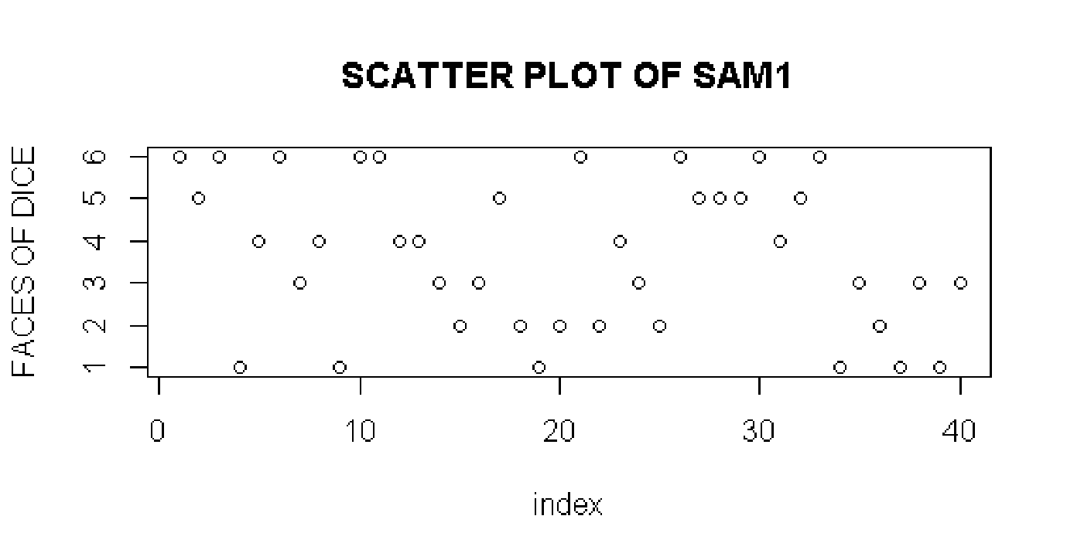

> plot(sam2,main = "SCATTER PLOT OF SAM2" ,xlab = "index",ylab = "FACES OF DICE")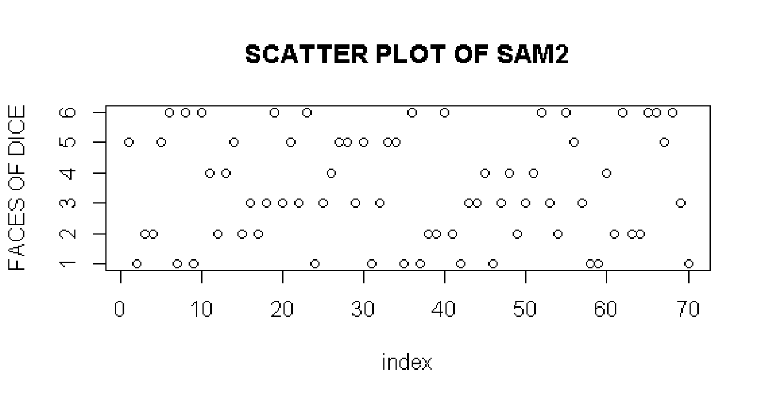

> plot(sam3,main = "SCATTER PLOT OF SAM3" ,xlab = "index",ylab = "FACES OF DICE")

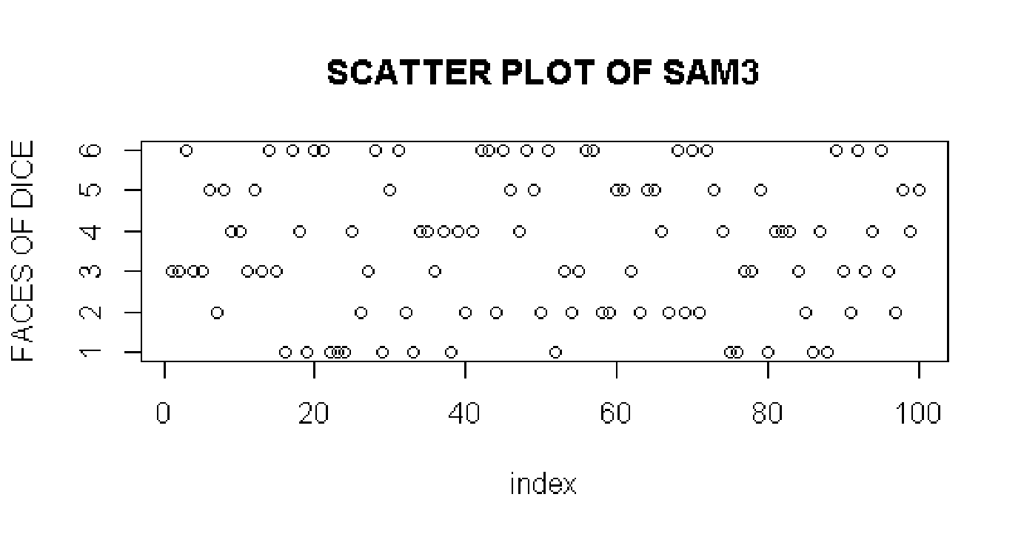

Q16. Create bar chart for frequency distribution obtained in Q 13. Add simple adornments. Apply

grayscale color shading scheme to reflect frequencies.

ANS:

> barplot(t1, main = "BAR PLOT OF SAMPLE 1", xlab = "Faces of dice", ylab = "Frequency", border = "Red", col = gray(1-rel1))

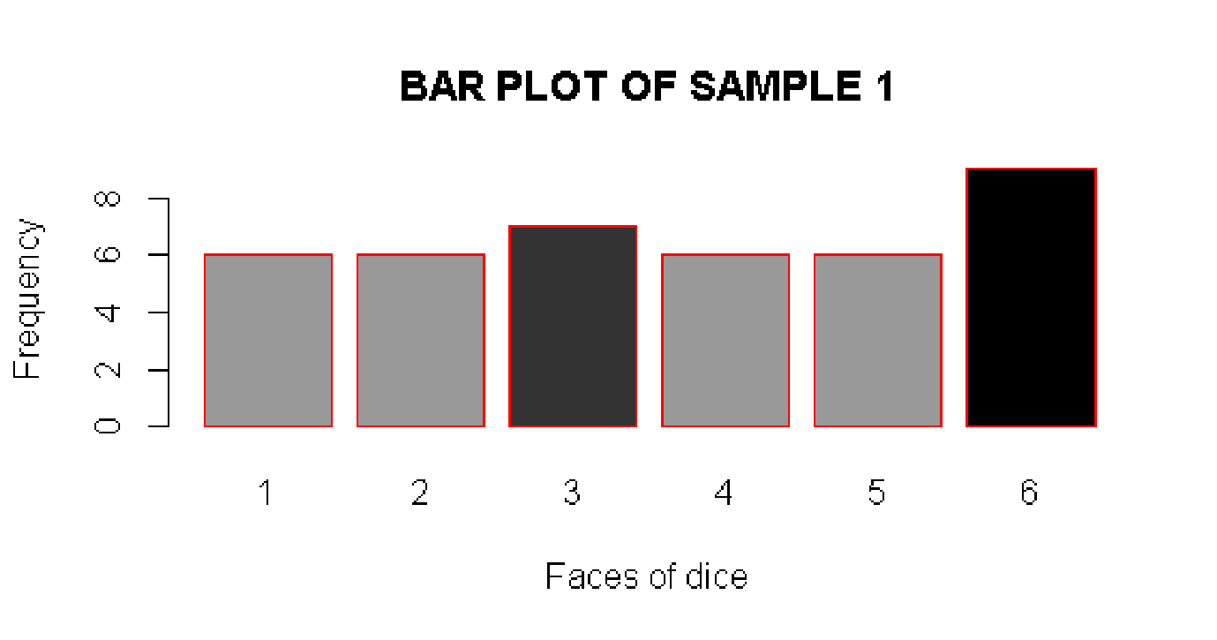

> barplot(t2, main = "BAR PLOT OF SAMPLE 2", xlab = "Faces of dice", ylab = "Frequency", border = "GReen", col = gray(1-rel2))

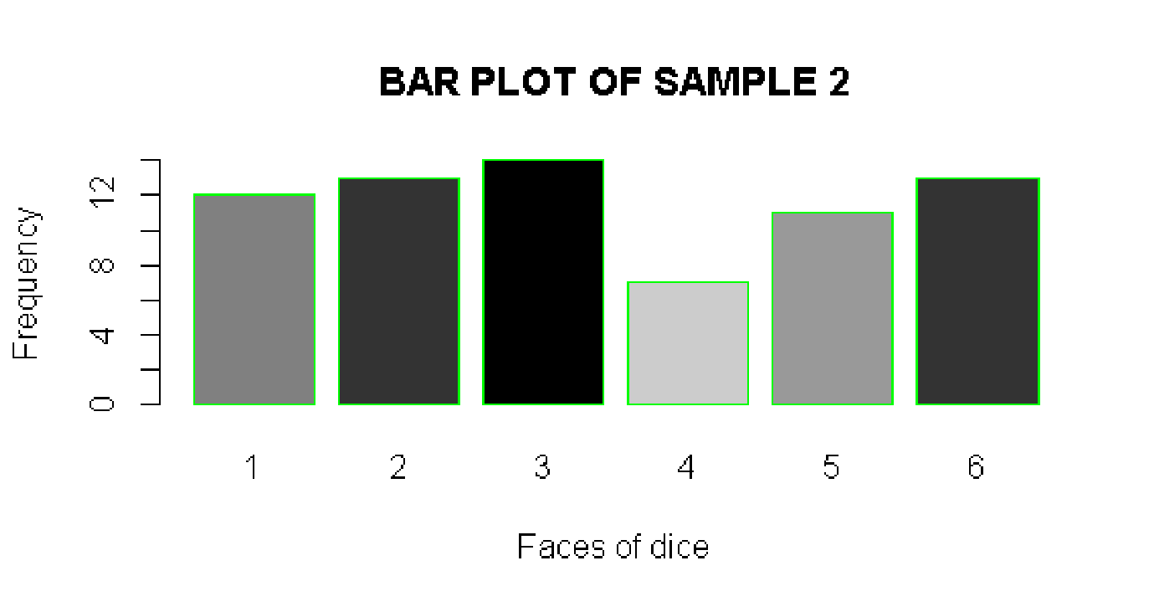

> barplot(t3, main = "BAR PLOT OF SAMPLE 3", xlab = "Faces of dice", ylab = "Frequency", border = "yellow", col = gray(1-rel3))

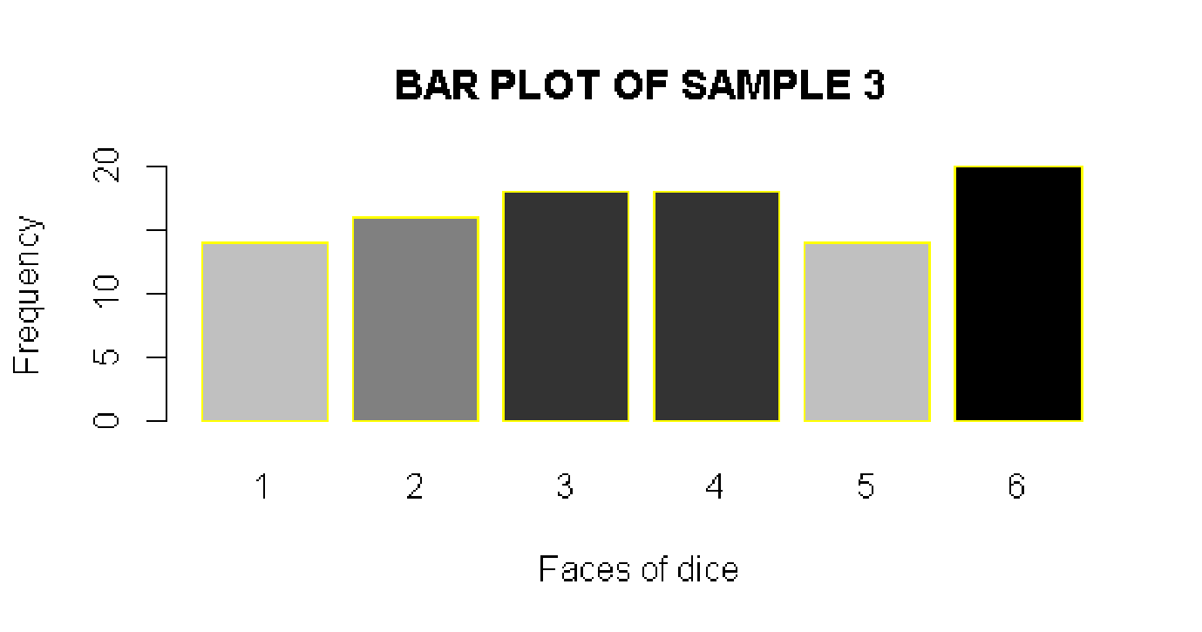

Q. Draw a sample of 1000 observations from a standard normal distribution and plot a histogram of the observations with 100 bins (cells). Now draw 10000 observations and plot a histogram with 100 bins. What do you notice as you increase the sample size?

ANS:

> x1<-rnorm(1000,mean = 0,sd = 1)

> hist(x1,100)

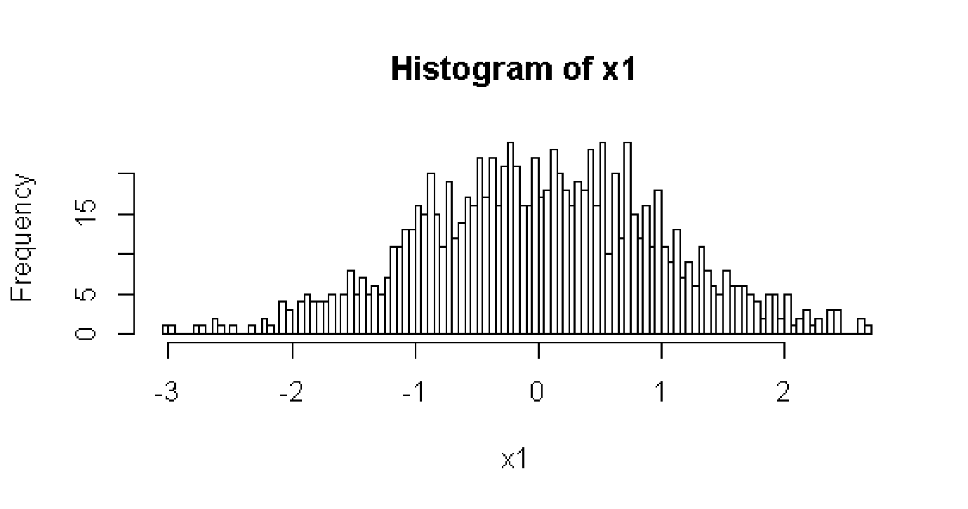

> x1<-rnorm(10000,mean = 0,sd = 1)

> hist(x1,1000)

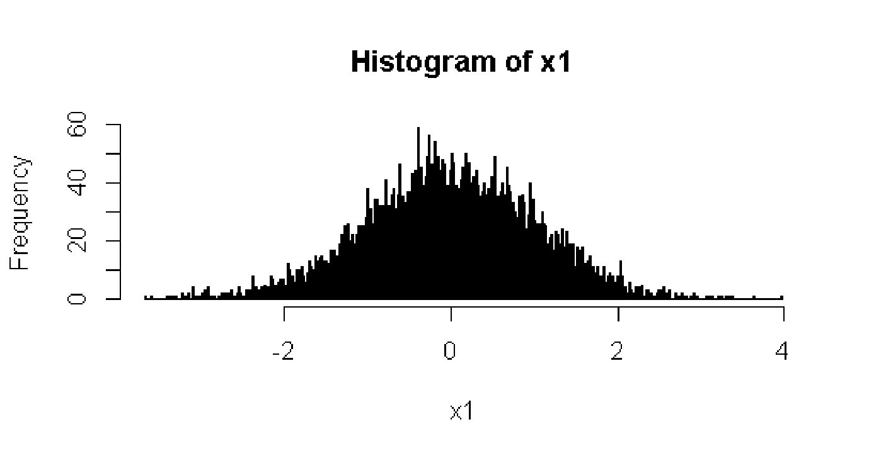

From the Above Two Histograms We Noticed That If We Increase The Bin Size the sample tends towards normal distribution